BSDA2001P — Introduction to DL and GenAI
Smart MCQ Solver — Project Report
Fine-Tuned Transformer, a Custom RNN, and a Classical Baseline for MCQ Answer Ranking (MAP@3) — Kaggle: Smart MCQ Solver Challenge | 23f2004341

1. Abstract / Executive Summary
The Smart MCQ Solver Challenge (Kaggle) presents questions with five candidate answers (A–E); the task is to rank the top-3 likely-correct options, scored by MAP@3 — so ranking quality, not just top-1 accuracy, matters.
Three approaches were built and compared: (1) TF-IDF + Logistic Regression, treating each prompt–option pair as independent binary classification; (2) a custom BiLSTM, also framed as binary relevance classification, with a hand-built vocabulary and imbalance-aware loss weighting; and (3) a fine-tuned microsoft/deberta-v3-base transformer using Hugging Face's AutoModelForMultipleChoice head, which scores all 5 options jointly via a shared softmax — the framing best matched to MAP@3. All three were combined in a weighted rank-ensemble.
EDA revealed heavy near-duplication: only 588 unique option-sets across 2,000 train rows, and 91.6% of test option-sets exactly match a train option-set with a verified unique answer. This was exploited via a deterministic lookup table that overrides the model prediction for matched test rows.
Validation results: TF-IDF reached 91.9% binary accuracy (F1=0.820); BiLSTM reached 85.4% accuracy (F1=0.733); DeBERTa reached OOF MAP@3=0.7245 via group-aware 5-fold CV (grouped by option-set to prevent duplicate leakage). The final ensemble weights are TF-IDF/LSTM/DeBERTa = 0.10/0.00/0.90 — DeBERTa dominates, TF-IDF lightly tie-breaks, and the BiLSTM is effectively excluded.
Key takeaways: group-based CV is essential on duplicated data; framing MCQ as joint 5-way ranking (DeBERTa) suits MAP@3 better than independent binary scoring; and exploiting train/test duplication has an outsized effect relative to modelling gains on this dataset.

2. Introduction

2.1 Problem Statement & Metric
Each row of train.csv (2,000 rows) / test.csv (500 rows) has an id, prompt, options A–E, and (train only) the correct answer letter. A model must output the 3 most-likely option letters, ranked, per question (e.g. "B E D"). Scoring is Mean Average Precision at 3 (MAP@3): 1 if the true answer ranks 1st, 1/2 if 2nd, 1/3 if 3rd, else 0, averaged over all questions.

2.2 Objectives
- Compare a classical baseline, a custom RNN, and a fine-tuned transformer on the same task, framed correctly for each architecture (binary relevance vs. joint 5-way ranking).
- Use group-aware cross-validation to get a trustworthy local metric despite heavy row duplication.
- Track experiments with Weights & Biases; combine base models into a weighted ensemble.

3. Dataset & Preprocessing

3.1 Dataset & EDA
train.csv: 2,000 rows × 8 cols (id, prompt, A–E, answer). test.csv: 500 rows × 7 cols (no answer). Each question is consumed as five (prompt, option) pairs.
Key EDA finding — heavy near-duplication: a normalized "option-set key" (sorted, lower-cased text of the 5 options) collapses reworded copies of the same question to one key. Only 588 unique option-sets exist across 2,000 train rows (29.4% unique), with zero label conflicts within any group. 458/500 test rows (91.6%) exactly match a train option-set. This makes naive row-level K-fold validation unreliable (it inflated local MAP@3 to ~0.97 vs. an actual leaderboard score of ~0.75); grouping folds by option-set instead gives a trustworthy OOF MAP@3 of 0.7245 (Section 5.1). Answer-letter distribution and vocabulary word-frequency were also logged to wandb (data/answer_distribution, data/top_words).

3.2 Preprocessing & Augmentation
For TF-IDF/BiLSTM: each question is expanded into 5 binary-labelled rows (10,000 examples total; label=1 if that option is correct), text combined as prompt + option per pair. For DeBERTa: the 5 options stay grouped and are tokenized as 5 (prompt, option) pairs sharing one label (0–4), matching AutoModelForMultipleChoice's native input format. No synthetic augmentation was applied; the dataset's natural duplication was instead exploited directly via the lookup table (Section 5.3).

4. Tokenization Strategy
Best-performing model (DeBERTa-v3-base) uses its pre-trained SentencePiece-style AutoTokenizer (~128K subword pieces, trained jointly with the encoder). Subword tokenization suits this task because prompts/options contain technical vocabulary ("redshift", "Landau–Lifshitz–Gilbert") that a small hand-built vocabulary would drop as unknown or represent too sparsely; subwords back off gracefully and already carry pre-trained semantic structure. Implementation: transformers v4.46.3 AutoTokenizer + AutoModelForMultipleChoice; each question's 5 (prompt, option) pairs are tokenized together (truncation=True, max_length=320) with dynamic per-batch padding via a multiple-choice-aware collator.
Model | Tokenizer | Vocabulary | Notes
TF-IDF+LR | TfidfVectorizer | 50,000 feat., 1–2 grams | English stop-words removed; bigrams catch short phrases.
BiLSTM | Hand-built whitespace | 3,816 tokens (min count 2) | Lower-cased; rare words → <UNK>; fixed-length pad/truncate.
DeBERTa-v3 | Pre-trained SentencePiece | ~128,000 subwords | Joint encoder pre-training; handles rare/technical terms via subword back-off.

5. Modeling & Experimentation
Three approaches were built, presented in guideline order. Note: the guideline's Model 2 slot calls for a custom deep-learning architecture distinct from the RNN in Model 3; the notebooks provide a classical TF-IDF+LR baseline instead, used here as the non-transformer baseline. Adding a text-CNN would give full compliance.

5.1 Model 1: Fine-Tuned Transformer — DeBERTa-v3-base
Architecture: microsoft/deberta-v3-base (He et al., 2021) with Hugging Face's AutoModelForMultipleChoice head. DeBERTa uses disentangled attention (separate content/position vectors per token) and an enhanced mask decoder; DeBERTaV3 pre-trains with ELECTRA-style replaced-token-detection for stronger representations at the same size. The head runs the shared encoder once per (prompt, option) pair, pools each into a score, concatenates the 5 scores, and applies softmax — directly optimizing the joint-ranking structure MAP@3 rewards. Disentangled attention helps distinguish options that share wording but differ in a key relative phrase (e.g. "z = 6.0" vs. "z = 16.7").
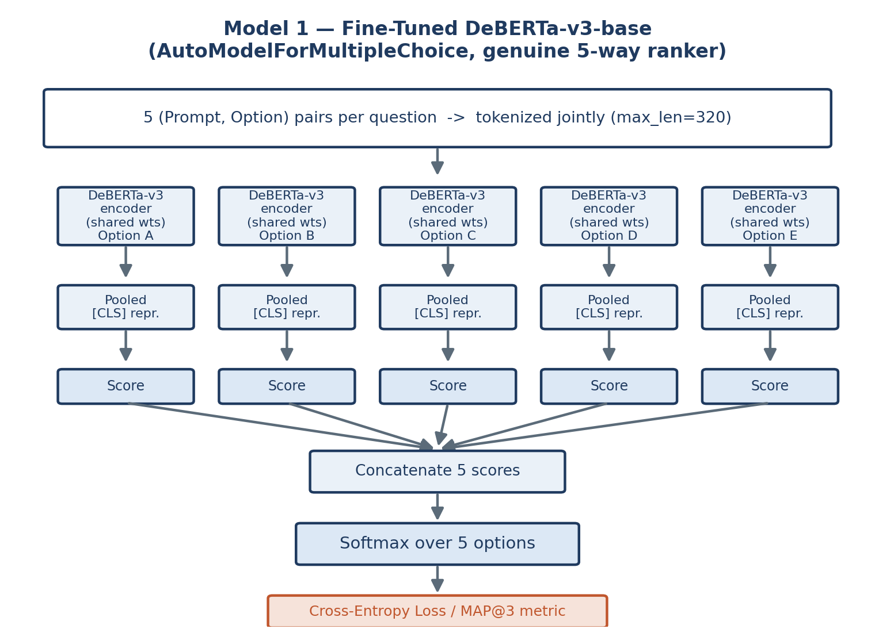
Fig. 1 — DeBERTa scores all 5 options through a shared encoder, ranked via joint softmax.
Fine-tuning: AdamW, lr=1e-5, weight decay 0.01, cosine schedule w/ 10% warmup, 6 epochs, batch 4 × grad-accum 2 (eff. 8), fp16, no frozen layers. 5-fold GroupKFold grouped by option-set key — the key methodological choice, since ungrouped folds let duplicate questions leak across train/val and inflate local MAP@3 to ~0.97 vs. an actual ~0.75 leaderboard score. metric_for_best_model="map3" (custom compute_metrics implementing the competition formula exactly) selects checkpoints. No quantization; fp16 mixed precision only, on a Tesla T4.

5.2 Model 2: Baseline — TF-IDF + Logistic Regression
Architecture: Each (prompt, option) pair → TfidfVectorizer (max_features=50,000, ngram_range=(1,2), English stop-words removed) → Logistic Regression (class_weight="balanced", max_iter=1000) predicting P(correct). class_weight="balanced" matters since only 1-in-5 pairs is positive; bigrams catch short discriminative phrases (e.g. "light-ion fusion") a unigram bag-of-words would miss. Serves as a fast, interpretable lower bound with no shared representation across a question's 5 options — measuring how much of the task surface lexical overlap alone can solve.
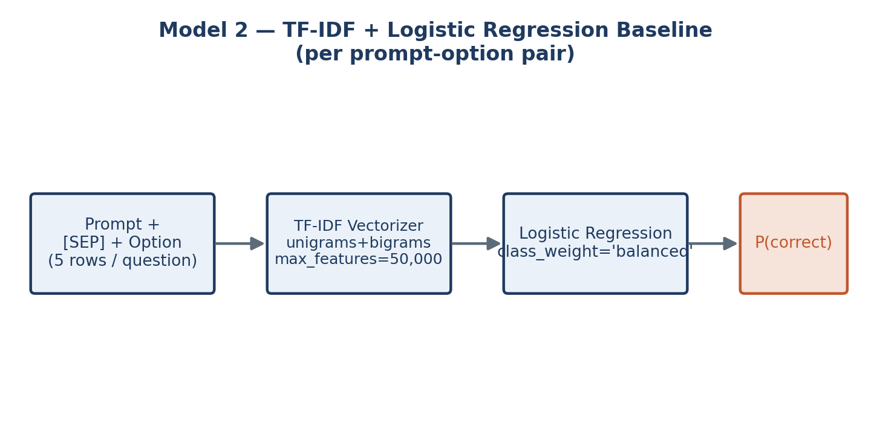
Fig. 2 — TF-IDF + Logistic Regression: a fast, purely lexical baseline.

5.3 Model 3: RNN-Based — Bidirectional LSTM
Architecture: Custom PyTorch BiLSTM: nn.Embedding (vocab 3,816, dim 256, pad_idx 0) → 2-layer bidirectional nn.LSTM (hidden 256/direction, dropout 0.4) → last-timestep output (512-d) → dropout → Linear(512,1) → BCEWithLogitsLoss (pos_weight=4.0 for the same 1-in-5 imbalance). 3,607,041 trainable params. Bidirectionality lets the encoder use both-direction context before scoring; sequence modelling suits this task since correctness often hinges on relational/negated phrasing (e.g. "exist without..." vs. "do not exist without...") that bag-of-words conflates. Input: prompt/option each truncated to 64 tokens → 128-token sequence. Optimizer: AdamW, lr=1e-3, CosineAnnealingLR, 10 epochs, grad-norm clipped to 1.0. Vocabulary built from scratch (min count 2) — no pre-trained knowledge, unlike DeBERTa.
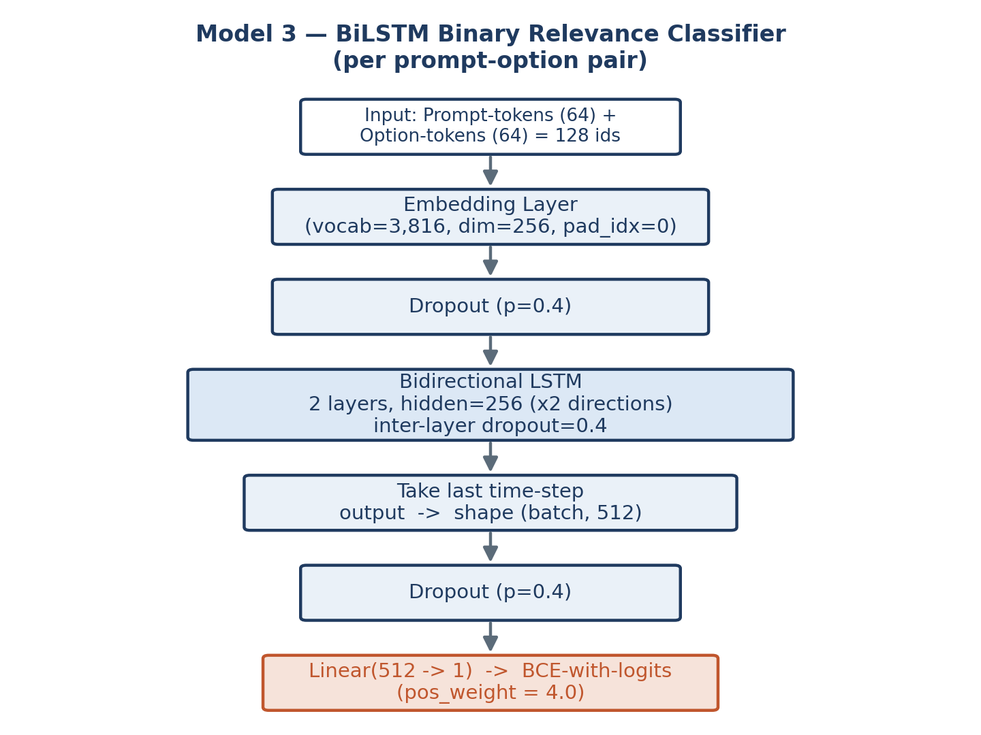
Fig. 3 — Custom BiLSTM: embed → bidirectional encode → single relevance score.

6. Performance & Comparative Analysis
MAP@3 is the competition metric (Sec. 2.1). TF-IDF/BiLSTM report binary accuracy/F1/precision/recall on held-out prompt–option pairs (they don't produce MAP@3 directly); DeBERTa reports OOF MAP@3 via group-aware 5-fold CV — the metric most comparable to the leaderboard.
Model | Task framing | Validation metric | Value
TF-IDF + LR | Binary relevance | Acc / F1 | 0.919 / 0.820
BiLSTM (10 ep.) | Binary relevance | Acc / F1 (best, ep.9) | 0.855 / 0.733
DeBERTa-v3-base | Joint 5-way ranking | OOF MAP@3 (5-fold) | 0.7245
Not directly comparable — the first two score isolated pairs, MAP@3 scores whole-question ranking — but TF-IDF's high accuracy is driven by the easy 4/5 "incorrect" majority class, while DeBERTa solves the strictly harder joint-ranking task and is the only metric directly interpretable in the competition's own terms.

BiLSTM training
10 epochs, 90/10 split; per-step loss/grad-norm/lr logged to wandb. Training was unstable early (val. acc. dropped to 0.237 at epoch 3, a from-scratch embedding + lr=1e-3 settling in) before recovering to best F1=0.733 at epoch 9 (acc.=0.855). Final report: recall=1.00, precision=0.58 on the positive class (confusion matrix: 654 TN, 146 FP, 0 FN, 200 TP) — pos_weight=4.0 makes it over-predict "correct", by design.

DeBERTa 5-fold OOF MAP@3
Fold 1 | Fold 2 | Fold 3 | Fold 4 | Fold 5 | Overall OOF
0.7158 | 0.7654 | 0.8279 | 0.6363 | 0.6771 | 0.7245
Fold variance (0.636–0.828) is expected with ~400 val. questions/fold; the overall OOF figure is the trustworthy generalization estimate since no fold sees a question's option-set twice..

6.2 Train/Test Duplicate Lookup (Largest Single Lever)
Since 91.6% of test option-sets exactly match a train option-set with a verified unique answer (Sec. 3.1), a lookup table (option-set → correct answer) overrides DeBERTa's top-ranked prediction for matched rows; the model's own ranking fills ranks 2–3, and is used fully for the 8.4% unmatched rows. Two submission variants (model-only, lookup-augmented) were produced to A/B test on the live leaderboard — this exploits a documented dataset property rather than reflecting stronger language understanding, and should be reported as such.

6.3 Ensemble
Weighted rank-ensemble: each model's top-3 ranked pick contributes weight×(3−rank) per option; scores sum across models; top-3 by combined score wins. Weights: tfidf=0.10, lstm=0.00, deberta=0.90 — so the BiLSTM is present in the pipeline but contributes nothing to the final blend. Top-1 agreement: TF-IDF vs. Ensemble=92.6%, DeBERTa vs. Ensemble=100.0% (expected, given its dominant weight), LSTM vs. Ensemble=79.0% (correlational only — zero causal weight). Consensus and score-margin diagnostics were also logged to wandb (charts/top1_distribution, model_agreement_heatmap, score_margin_distribution, consensus_distribution).
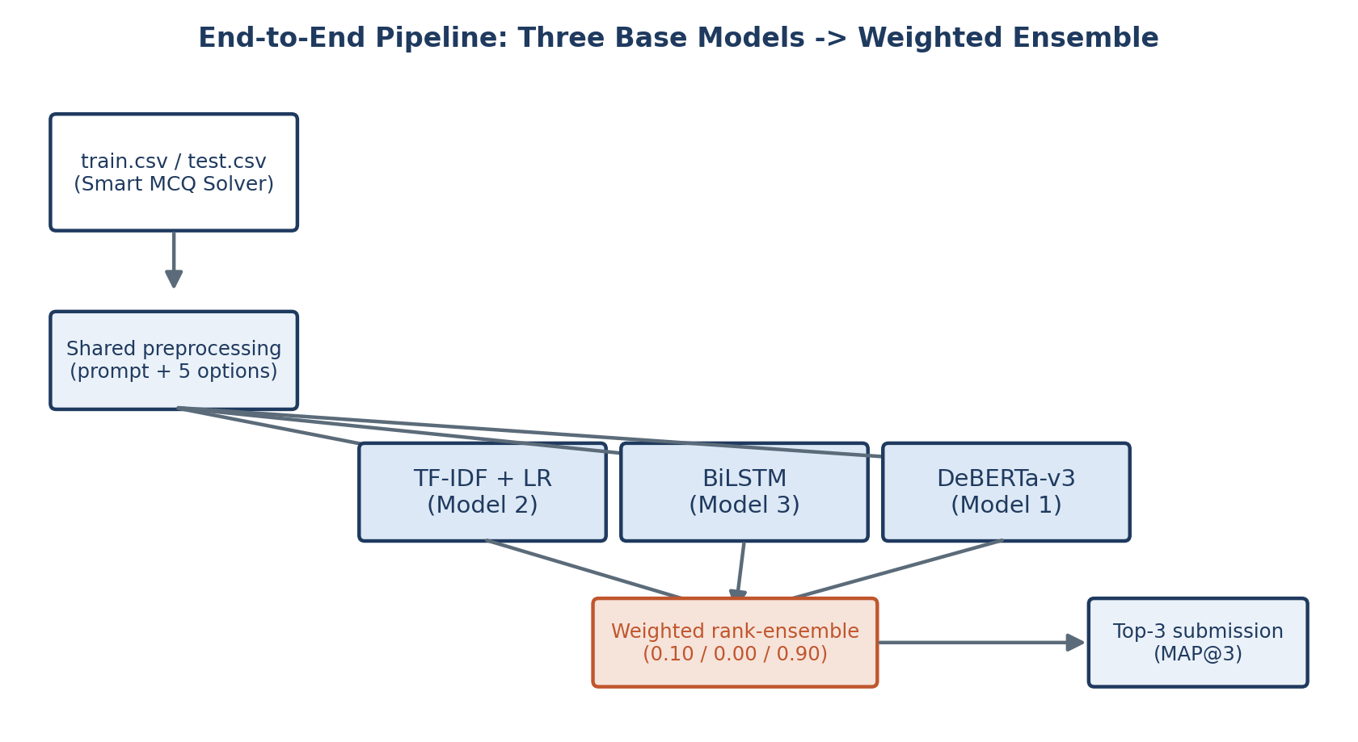
Fig. 4 — Three base models feed a weighted rank-ensemble producing the MAP@3 submission.

Trade-offs
Dimension | TF-IDF+LR | BiLSTM | DeBERTa-v3
Train cost | Seconds (CPU) | Minutes (GPU) | Hours (GPU, 5×6 ep.)
Params | ~11K feat.+weights | 3.6M | ~184M
Pre-trained? | No | No (from scratch) | Yes (+ELECTRA-style)
Framing | Independent binary | Independent binary | Joint 5-way

7. Conclusion & Future Work

7.1 Key Learnings & Challenges
- Task framing matters as much as capacity: DeBERTa's joint 5-way ranking suits MAP@3 better than independent binary classifiers (TF-IDF, BiLSTM), even before its larger pre-trained representation is considered.
- Group-aware CV is essential on duplicated data — naive K-fold inflated local MAP@3 to ~0.97 vs. an actual ~0.75; grouping by option-set gave a trustworthy 0.7245 OOF estimate.
- Understanding dataset construction (train/test question reuse, 91.6% overlap) can move the leaderboard score more than architecture choices.
- Class-imbalance handling (balanced weights / pos_weight=4.0) is essential once MCQ is converted to binary classification (1-in-5 positive rate).
- A live W&B API key was found hard-coded in 03-lstm-ipynb.ipynb — rotate it and load via Kaggle Secrets instead, as the other notebooks correctly do.
- BiLSTM training was unstable early (val. acc. dipped to 0.237 at epoch 3), requiring full 10-epoch training and best-checkpoint selection rather than assuming monotonic improvement.

7.2 Future Work
- Add a distinct custom deep-learning model (text-CNN / attention-pooled BiLSTM) to fully satisfy the guideline's 3-model structure.
- Reframe the BiLSTM as a joint 5-way ranker (shared encoder + softmax, mirroring the DeBERTa head) to better align with MAP@3.
- Try deberta-v3-large and/or 8–10 folds, per the transformer notebook's own next-step notes.
- Tune ensemble weights systematically rather than by hand; re-evaluate the BiLSTM's weight (currently 0.00) once recalibrated.
- Quantify the lookup table's leaderboard impact directly (model-only vs. lookup-augmented scores); investigate DeBERTa's fold-variance (0.636–0.828) via per-optkey error analysis.

8. References
He, P., Gao, J., & Chen, W. (2021). DeBERTaV3: Improving DeBERTa using ELECTRA-Style Pre-Training with Gradient-Disentangled Embedding Sharing. arXiv:2111.09543.
He, P., Liu, X., Gao, J., & Chen, W. (2021). DeBERTa: Decoding-enhanced BERT with Disentangled Attention. ICLR. | Model card: huggingface.co/microsoft/deberta-v3-base
Hochreiter, S., & Schmidhuber, J. (1997). Long Short-Term Memory. Neural Computation, 9(8), 1735–1780.
Schuster, M., & Paliwal, K. K. (1997). Bidirectional Recurrent Neural Networks. IEEE Trans. Signal Processing, 45(11), 2673–2681.
Salton, G., & Buckley, C. (1988). Term-weighting Approaches in Automatic Text Retrieval. Info. Processing & Mgmt., 24(5), 513–523. (TF-IDF)
Pedregosa, F., et al. (2011). Scikit-learn: Machine Learning in Python. JMLR, 12, 2825–2830.
Wolf, T., et al. (2020). Transformers: State-of-the-Art NLP. Proc. 2020 EMNLP: System Demos.
Paszke, A., et al. (2019). PyTorch: An Imperative Style, High-Performance DL Library. NeurIPS 2019.
Loshchilov, I., & Hutter, F. (2019). Decoupled Weight Decay Regularization (AdamW). ICLR 2019.
Biewald, L. (2020). Experiment Tracking with Weights and Biases. wandb.com
Kaggle. Smart MCQ Solver Challenge. [Insert competition URL.]

